**Class:** Final Year (Computer Science and Engineering)

**Year:** 2021-22 **Semester:** 1

**Course: High Performance Computing lab**

**ESE Exam**

**23/11/2021**

**01.00 PM – 04.00 PM**

**Exam Seat No:**

Name: Purva Kudre

Exam Seat Number: 2018BTECS00095

**Problem Statement 1**

**Statement:** Implement Fibonacci Series using OpenMP.

**Screenshot 1.1:**

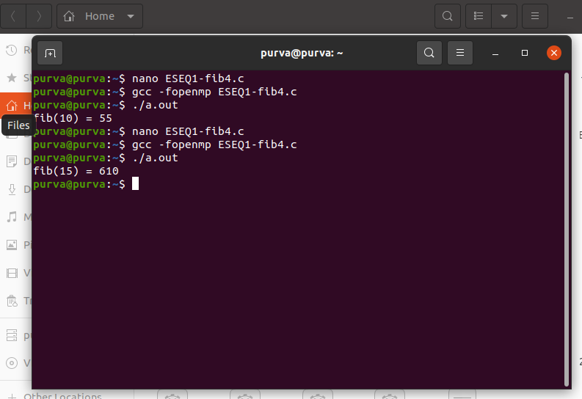

**Information 1.1:** Above is the screenshot of a Fibonacci Series Program implemented using OpenMP.

**Screenshot 1.2:**

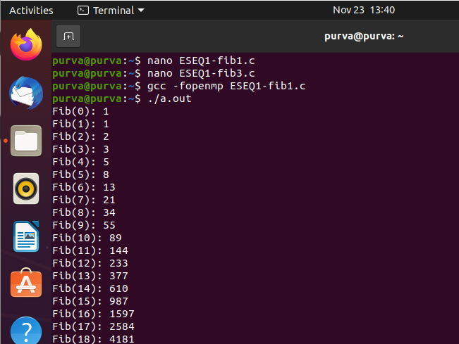

**Information 1.2:** Above is the screenshot of a Recursive Fibonacci Series Program in OpenMP.

**Problem Statement 2**

**Statement:** Implement MPI program to scatter the data from one process to other process.

**Screenshot 2.1:**

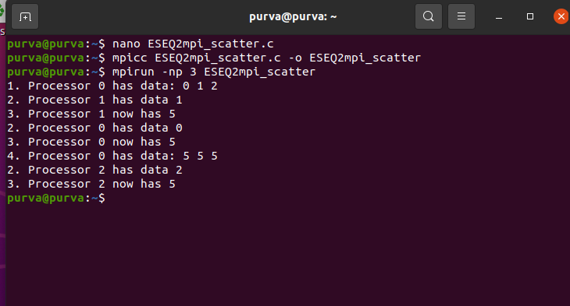

**Information 2.2:** Above is the screenshot of an implementation of an MPI program to scatter data from one process to other process

**Problem Statement 3**

**Statement:** Implement Vector-vector multiplication using CUDA.

**Screenshot 3:**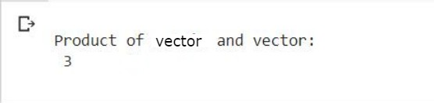

**Information 3:** Above is the screenshot of the Implementation of Vector-Vector multiplication using CUDA.  
The Vectors are <2,1> and <3,-2>

**Technologies Used:**

1. **Virtual box – Ubuntu 20.04**
2. **Google “Colab”**

**GitHub Link:** [**https://github.com/Psk1999/HPC_LA3**](https://github.com/Psk1999/HPC_LA3)